**DASHBOARD FOR SKILL MANAGEMENT OF EMPLOYEES**

Name : Madham Mounika

EmpID : 70983735

**Given Task :** Develop an Application for Skill Management of Employees , Create Dashboard to display skill wise and other KPIs, we should be able to search for employees based on skills ,rating, experience ,certifications etc.

**Technologies Used:**

* **Frontend :** Angular(VScode)
* **Backend :** Spring Boot(IntelliJ)
* **Database :** PostgreSQL
* **API :** Postman

**Implementation Part:**

**Frontend:**

* According to the given task a dashboard with employee details should be created using Angular . Employee Details includes Employee Id, Name, Skill, Experience, Rating, Certifications, KPI.
* In Home page, the skill-wise employee details are displayed on dashboard.
* In Register page, employee can able to register by adding their skills & information.
* In Employee page, the details of employees are displayed.
* In Search page, the employee details are displayed, given task is that need to be able to search for employees based on skills, rating, experience , certifications.
* To search the element, custom filter pipe is used for searching, the filtered details of employees are displayed based on searching attribute.

In home page, the skill-wise employee details are displayed on dashboard.

In Register page, employee can able to register by adding their skills & information.

In employee page, the details of employees are displayed.

In Search page, the employee details are displayed, given task is that need to be able to search for employees based on skills, rating, experience , certifications.

**Backend:**

For Backend Spring boot is used to create Rest API in IntelliJ platform.

In IntelliJ, By creating the maven project for spring boot application and connect to the database by using postman & database is PostgreSQL to store data.

The project Structure of Spring boot is :

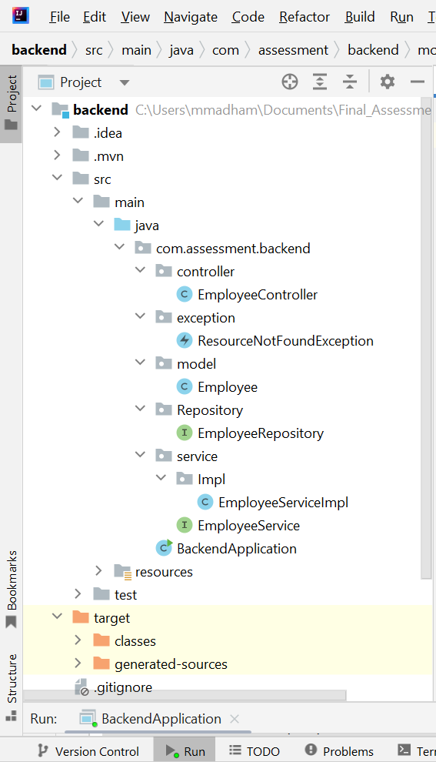

To add the data into database by using postman post request.

And the database in table, data is created in the PostgreSQL.

Retrieving the data from the database by using the postman Get request.

Retrieving the data with specific Id from the database using postman Get Request.

Deleting the specific data row from database using the Delete Request.

Updating the details of specific employee by using the Put Request in postman.

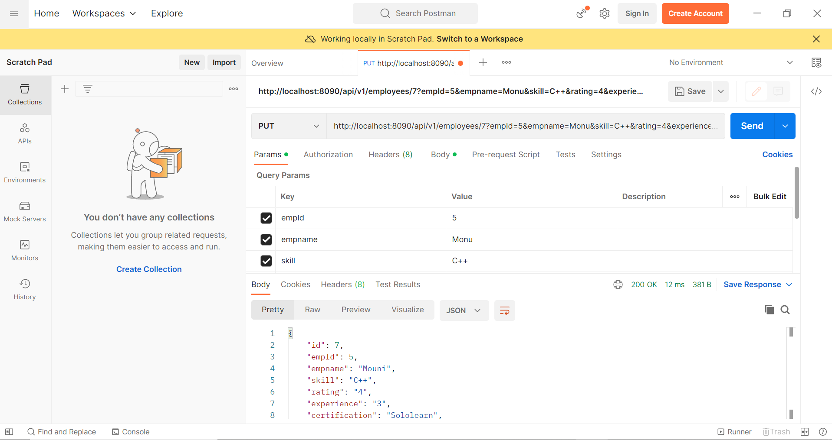

Here is the updated database.

**Rest API links:**

To Get data: ***http://localhost:8090/api/v1/employees***

To Add data: [***http://localhost:8090/api/v1/employees***](http://localhost:8090/api/v1/employees)

To update data: [***http://localhost:8090/api/v1/employees/{id}***](http://localhost:8090/api/v1/employees/%7bid%7d)

To delete data:[***http://localhost:8090/api/v1/employees/{id}***](http://localhost:8090/api/v1/employees/%7bid%7d)